Name: Jake Hafele and Caitie Steele

Email: [jmhafele@iastate.edu](mailto:jmhafele@iastate.edu), [crsteele@iastate.edu](mailto:crsteele@iastate.edu)

Purpose for project (for fun or for which class): For fun

Address (where and to whom should we send the parts?):

Send to Jake at 4209 Ontario Street, Ames Iowa 50014

Critical Tinkers Project Proposal:

Side Table LED Lights

# Project Overview:

# For this project, me and Caitie wanted to make our own small tables for our rooms. We bought the wood and materials already from Menards for the tables, but we also wanted to add LED strips to backlight it. To do this, I am going to design an Arduino PCB that has a transceiver, buttons, switches, and connectors to add the LED strips to the board. Once the PCB and parts come in, the hardware side of the project should go pretty fast. It will take more time to code the LED strips how I want them, but that can be worked on over time after the project is technically “finished”

# Outline the steps/plan for your project:

*This is where you complete a plan for your project please include project timeline and parts list for each step. Add more steps and parts lists if you need it. After each step and after you send me(* [*wjung@iastate.edu*](mailto:wjung@iastate.edu) *or* [*tjj1@iastate.edu*](mailto:tjj1@iastate.edu)*) the pictures or video of the previous step, CT will fund the next step of your project. Please keep parts to under $150 for each* ***step****.*

**Step 1**

Description of step 1

Build the actual table. We painted the wood pieces already and are planning on putting them together soon if it isn’t done already. This is all handled on our end and doesn’t require any electronics

Time expected to complete step 1: A couple days. DONE ALREADY

Parts list: None

**Step 2**

Description of step 2

Designing the PCB and figuring out which parts to order.

Time expected to complete step 2: A Week

Parts list:

* Power Strip sockets (2, $14 each)<https://www.amazon.com/Conference-Recessed-Desktop-Grommet-2-Outlet/dp/B071ZG9Q45/ref=sr_1_5?dchild=1&keywords=desk+power+outlet+with+usb&qid=1612455020&sr=8-5>
* WS2812B 30 LEDs/meter 5 meter roll (1, $27) <https://www.amazon.com/ALITOVE-WS2812B-Individually-Addressable-Waterproof/dp/B00ZHB9M6A>
* DC Wall Adapters (2, $19 each) <https://www.amazon.com/Geekworm-Adapter-Raspberry-Expansion-Management/dp/B07413Q5Y4/ref=sr_1_8?dchild=1&keywords=4+amp+power+supply+5v&qid=1613017220&sr=8-8>
* JLC PCB Order (5 boards (lowest amount), $10-20 depending on shipping), will attach zip file for order
* Digikey PCB Parts ($80 each), will attach excel sheet for BOM bulk order on digikey

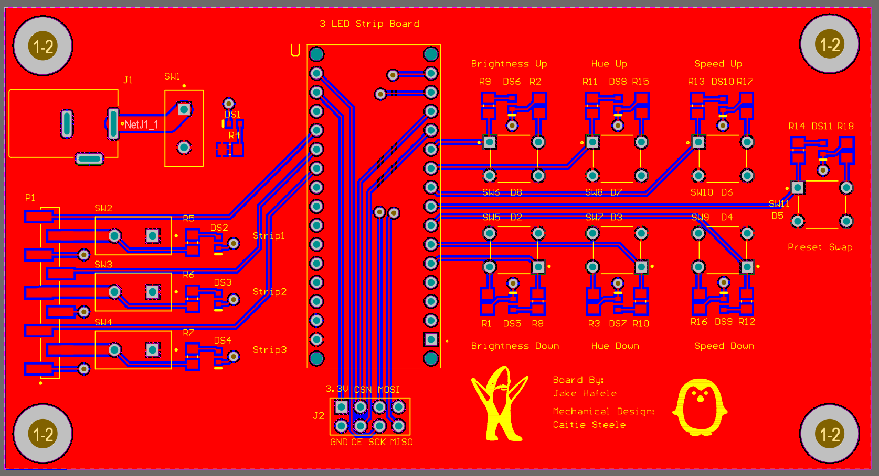

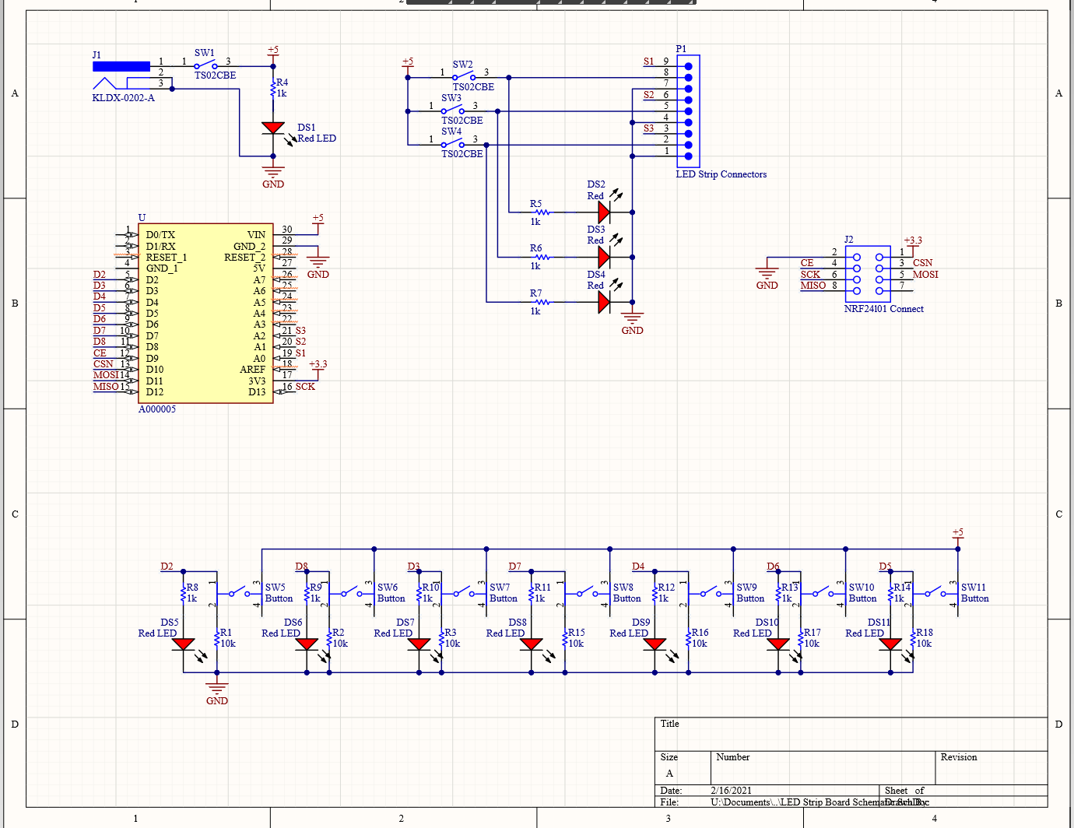

**Step 3**

Description of Step 3

Putting everything together and coding. We shouldn’t need any more parts at this point as long as the PCB and parts work as planned. So no parts here hopefully!

Time expected to complete step 3: About a week to put together the board and figure out led strips

Parts list:

* None

***Please email pictures or videos to*** [***wjung@iastate.edu***](mailto:wjung@iastate.edu) ***or*** [***tjj1@iastate.edu***](mailto:tjj1@iastate.edu) ***after completing each step or at any critical point that needs documentation!***